附件：裕民县历史遗留矿山基本情况表
序号 | 图斑编号 | 图斑小类 | 地理位置 | 图斑面积（m²） | 中心坐标 |  | 拐点坐标 | 图斑影像
 |  |  |  |  | 经度 | 纬度 | 拐点坐标 | 图斑影像
1 | ZJ6542252021002001 | 无法确认治理恢复责任主体的无主废弃矿山 | 塔城地区裕民县哈拉布拉乡乡 | 15597.12 | 83.10436 | 46.29698 | （序号.经度，纬度；）  1.83.10710037,46.29846628;  2.83.10731453,46.29849002  3.83.10744540,46.29844241  4.83.10768334,46.29844235  5.83.10787369,46.29835904  6.83.10806404,46.29831141  7.83.10830198,46.29823998  8.83.10850422,46.29823992  9.83.10861129,46.29820421  10.83.10877784,46.29814468  11.83.10896817,46.29808515  12.83.10907524,46.29800185  13.83.10915850,46.2978115  14.83.10914659,46.29766876  15.83.10909900,46.29751413  16.83.10899192,46.29740711  17.83.10882538,46.29740715  18.83.10859934,46.29741911  19.83.10840899,46.29739538  20.83.10819485,46.29739543  21.83.10804019,46.29743116  22.83.10792123,46.29750256  23.83.10777846,46.29751449  24.83.10764759,46.29746694  25.83.10751672,46.29746697  26.83.10733826,46.29744322  27.83.10725497,46.29744324  28.83.10708841,46.29745517  29.83.10688616,46.29763364  30.83.10681477,46.29771693  31.83.10673150,46.29785969  32.83.10671960,46.29793106  33.83.10675530,46.29802622  34.83.10686239,46.29818084  35.83.10689809,46.2982522  36.83.10696948,46.29834735  37.83.10710037,46.29846628 | 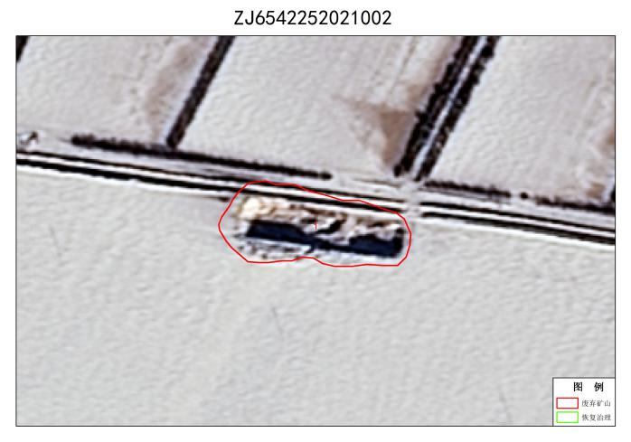
2 | ZJ6542252021003001 | 无法确认治理恢复责任主体的无主废弃矿山 | 塔城地区裕民县江格斯乡 | 38427.84 | 83.04213 | 46.30387 | 1.83.04188529,46.30444688  2.83.04207565,46.30449447  3.83.042266,46.30449447  4.83.04255153,46.30447067  5.83.04293224,46.30439929  6.83.04328917,46.3043755  7.83.04362229,46.30430411  8.83.04393162,46.30428032  9.83.04414577,46.30423272  10.83.04443131,46.30394719  11.83.04438372,46.30387581  12.83.04416956,46.30368546  13.83.04386024,46.30356648  14.83.04347952,46.30335233  15.83.04317019,46.30316197  16.83.04302742,46.30299541  17.83.04281328,46.30287644  18.83.04252774,46.30285265  19.83.0422898,46.30285264  20.83.04207564,46.30292402  21.83.04176631,46.30318577  22.83.04167114,46.30320956  23.83.04155216,46.30328095  24.83.04131421,46.30337612  25.83.04110006,46.3034713  26.83.0409573,46.30356648  27.83.04076694,46.30366166  28.83.04052899,46.30387581  29.83.04029105,46.3039234  30.83.04010069,46.30397099  31.83.03993413,46.30401858  32.83.03986274,46.30439929  33.83.03983895,46.30454206  34.83.03998172,46.30461344  35.83.04021966,46.30463724  36.83.04041002,46.30463724  37.83.04062417,46.30463724  38.83.04076693,46.30461344  39.83.04098108,46.30463724  40.83.04126663,46.30461345  41.83.04145698,46.30451826  42.83.04171872,46.30447068  43.83.04188529,46.30444688 | 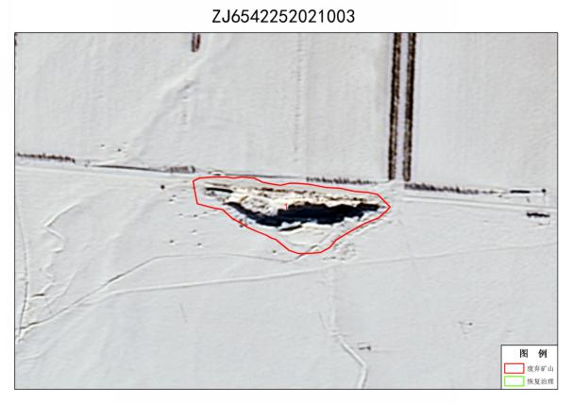
3 | ZJ6542252021010001 | 无法确认治理恢复责任主体的无主废弃矿山 | 塔城地区裕民县新地乡 | 4691.54 | 83.042885 | 46.224224 | 1.83.04265118.46.22426579  2.83.04272971.46.22447995  3.83.04277254.46.22462271  4.83.04290816.46.22483687  5.83.04305807.46.22492252  6.83.04322939.46.22491539  7.83.04332218.46.22482973  8.83.04325081.46.22463699  9.83.04320084.46.22443712  10.83.04306521.46.22428721  11.83.0430438.46.224173  12.83.04300096.46.22393743  13.83.04295099.46.22367331  14.83.04285819.46.22350912  15.83.04267973.46.22347344  16.83.04252269.46.2236519  17.83.04257266.46.22390888  18.83.04260121.46.22410875  19.83.04265118.46.22426579 | 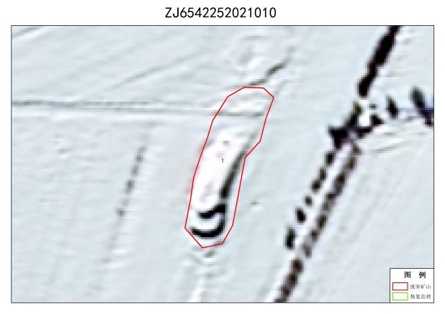
4 | ZJ6542252021012001 | 无法确认治理恢复责任主体的无主废弃矿山 | 塔城地区裕民县阿勒腾也木勒乡 | 12216.2 | 83.21819 | 46.173107 | 1.83.21794039,46.17376578  2.83.2181355,46.1737515  3.83.218402,46.1736706  4.83.2185638,46.17357542  5.83.21869706,46.17348025  6.83.21882555,46.17333748  7.83.21894452,46.17320899  8.83.21906349,46.17314236  9.83.21918722,46.17313285  10.83.21925861,46.17297104  11.83.21919674,46.17285207  12.83.21889692,46.172814  13.83.21873036,46.17277593  14.83.21857332,46.17269979  15.83.21829254,46.1725713  16.83.21812122,46.1724904  17.83.21799749,46.17246184  18.83.21780237,46.17246184  19.83.21769292,46.17256653  20.83.2176025,46.17269503  21.83.2174978,46.17285683  22.83.21741215,46.17294249  23.83.21739787,46.17307098  24.83.21743594,46.17320423  25.83.21747401,46.17337555  26.83.21753587,46.17344218  27.83.21759299,46.17353735  28.83.21769768,46.17362777  29.83.21780714,46.17372295  30.83.21794039,46.17376578 | 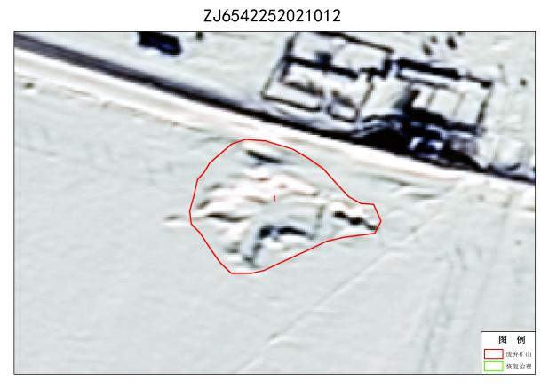
5 | ZJ6542252021018001 | 无法确认治理恢复责任主体的无主废弃矿山 | 塔城地区裕民县新地乡 | 12986.48 | 83.02587 | 46.09198 | 1.83.02566937,46.09253588  2.83.026269,46.09263583  3.83.02641176,46.09247878  4.83.02662591,46.09229318  5.83.02672585,46.09192198  6.83.02666874,46.09163645  7.83.02634037,46.09145085  8.83.02588352,46.09139374  9.83.02529817,46.09152224  10.83.02491269,46.09183632  11.83.02494125,46.09217897  12.83.02536956,46.09235028  13.83.02544094,46.09237884  14.83.02566937,46.09253588 | 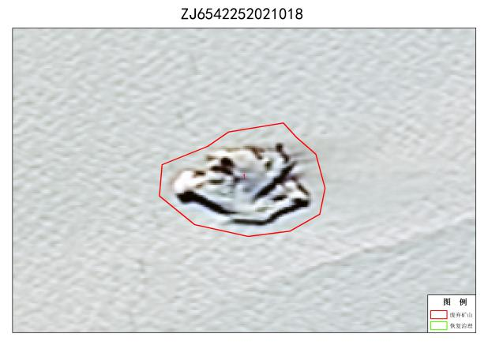
6 | ZJ6542252021020001 | 无法确认治理恢复责任主体的无主废弃矿山 | 塔城地区裕民县新地乡 | 11111.49 | 83.013084 | 46.224537 | 1.83.01250153,46.22508573  2.83.01276327,46.22512142  3.83.01306071,46.22514522  4.83.01321537,46.22501435  5.83.01342952,46.22484778  6.83.01367936,46.22468122  7.83.01382213,46.22451466  8.83.01396491,46.22439569  9.83.01404819,46.22421722  10.83.01394111,46.22405066  11.83.01369127,46.22399117  12.83.01341763,46.22391979  13.83.01315589,46.22403876  14.83.01283465,46.22415774  15.83.01262051,46.22427671  16.83.01238256,46.22439569  17.83.0122279,46.22455035  18.83.0122041,46.22465742  19.83.0122041,46.22483588  20.83.01235877,46.22500244  21.83.01250153,46.22508573 | 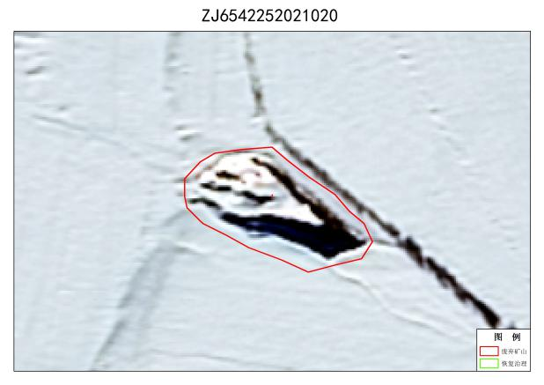
7 | ZJ6542252021004001 | 无法确认治理恢复责任主体的无主废弃矿山 | 塔城地区裕民县吉也克镇 | 3223.13 | 82.99723 | 46.29385 | 1.82.99719886,46.29414995  2.82.99745585,46.29413566  3.82.99759861,46.29407856  4.82.99765572,46.2939929  5.82.99765572,46.29377875  6.82.99754151,46.29366454  7.82.99732736,46.29359314  8.82.99717031,46.29355031  9.82.99699899,46.29355032  10.82.9968705,46.29362171  11.82.99678484,46.29365025  12.82.99681339,46.29385013  13.82.9968705,46.29396434  14.82.99697044,46.29406429  15.82.99708465,46.29410712  16.82.99719886,46.29414995 | 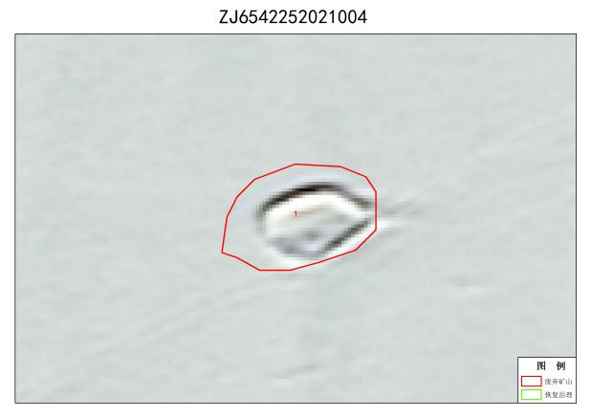
8 | ZJ6542252021024001 | 无法确认治理恢复责任主体的无主废弃矿山 | 塔城地区裕民县新地乡 | 10327.37 | 83.08855 | 46.26472 | 1.83.08846176,46.26524123  2.83.08908064,46.26516372  3.83.08939614,46.264979  4.83.08943302,46.26467635  5.83.08908622,46.26444469  6.83.08824573,46.26410484  7.83.08786222,46.26436685  8.83.08771244,46.26475432  9.83.08801134,46.26506648  10.83.08846176,46.26524123 | 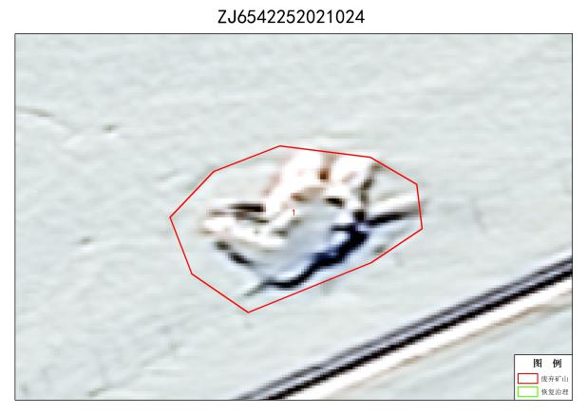
9 | ZJ6542252021008001 | 无法确认治理恢复责任主体的无主废弃矿山 | 塔城地区裕民县新地乡 | 25599.25 | 83.00761 | 46.219074 | 1.83.00673108,46.22026656  2.83.00686671,46.22019518  3.83.00700234,46.22016662  4.83.00709514,46.22010951  5.83.00722364,46.22001671  6.83.00731643,46.21996675  7.83.00745207,46.21991678  8.83.00754486,46.21985254  9.83.00765193,46.21981684  10.83.00776615,46.21964552  11.83.00787322,46.21958841  12.83.00794461,46.2195099  13.83.00813734,46.21940282  14.83.00818732,46.21931002  15.83.00826583,46.21921722  16.83.00838005,46.21916725  17.83.00846571,46.21908159  18.83.0085371,46.21898165  19.83.00865131,46.21890313  20.83.00872269,46.21881033  21.83.00882977,46.21866757  22.83.00893684,46.21850339  23.83.0089654,46.21835347  24.83.00889402,46.21826782  25.83.00882263,46.2182464  26.83.00874411,46.21823926  27.83.008687,46.21819643  28.83.00867986,46.21810363  29.83.00865845,46.21800369  30.83.00863704,46.21792517  31.83.0085942,46.21781096  32.83.00843002,46.21776099  33.83.00837292,46.21777527  34.83.00821587,46.21785379  35.83.00812307,46.21789662  36.83.00799458,46.21797514  37.83.00789464,46.21803938  38.83.00777329,46.21809649  39.83.0077019,46.21813932  40.83.00762338,46.21821785  41.83.00753772,46.21822499  42.83.0073664,46.21831779  43.83.00732357,46.21836061  44.83.00724505,46.21847483  45.83.00719508,46.21853908  46.83.00711656,46.21864615  47.83.00703804,46.21881034  48.83.00697379,46.21890313  49.83.0069381,46.21899593  50.83.00687385,46.21913156  51.83.00685244,46.21918153  52.83.00685243,46.21926004  53.83.00682389,46.21933857  54.83.00673822,46.21940996  55.83.00672394,46.21946706  56.83.0066954,46.21952417  57.83.00661687,46.21963839  58.83.00655263,46.21968835  59.83.00645982,46.21979543  60.83.00642414,46.21988823  61.83.00633133,46.21999531  62.83.00626709,46.22006669  63.83.00618143,46.22015235  64.83.00613146,46.22019518  65.83.00612432,46.22031653  66.83.00612432,46.22043788  67.83.00614574,46.22050213  68.83.00619571,46.2205164  69.83.00624567,46.22052354  70.83.00636703,46.22056638  71.83.00650979,46.22056637  72.83.00653121,46.22050927  73.83.00659545,46.22040933  74.83.00665256,46.22037364  75.83.00673108,46.22026656 | 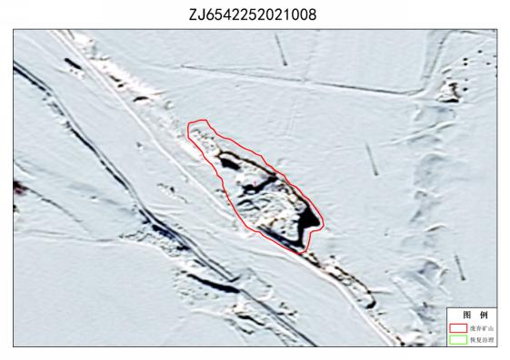
10 | ZJ6542252021022001 | 无法确认治理恢复责任主体的无主废弃矿山 | 塔城地区裕民县阿勒腾也木勒乡 | 36920.15 | 83.252525 | 46.161808 | 1.83.25152451,46.16220964  2.83.25195457,46.16238073  3.83.25236629,46.16260767  4.83.25300822,46.16284176  5.83.25318513,46.16307551  6.83.25360254,46.16315644  7.83.25391252,46.16298525  8.83.25390779,46.16248499  9.83.25384514,46.16222529  10.83.25361191,46.16177692  11.83.25347061,46.16156351  12.83.25324025,46.16104213  13.83.25309722,46.16076967  14.83.25287096,46.16055747  15.83.25229516,46.16070116  16.83.25127046,46.16105276  17.83.25085033,46.16155905  18.83.25083718,46.16179204  19.83.25112372,46.16201381  20.83.25152451,46.16220964 | 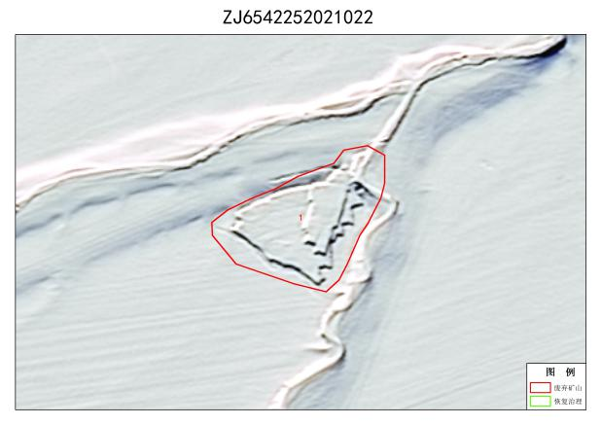
11 | ZJ6542252021011001 | 无法确认治理恢复责任主体的无主废弃矿山 | 塔城地区裕民县新地乡 | 19418.81 | 83.06149 | 46.23816 | 1.83.06104608,46.23861276  2.83.06102704,46.23878408  3.83.06114126,46.23897443  4.83.06114125,46.2391648  5.83.06119837,46.23929804  6.83.06124596,46.23935515  7.83.06133162,46.23939322  8.83.06143631,46.23945033  9.83.06163619,46.23941225  10.83.06179799,46.23937418  11.83.06192172,46.23925997  12.83.06196931,46.23906009  13.83.0620169,46.2388507  14.83.06204546,46.23866034  15.83.06205497,46.23846999  16.83.06208353,46.23826059  17.83.06212159,46.23797506  18.83.0621216,46.23778471  19.83.06212159,46.23764193  20.83.06206449,46.23741351  21.83.0619122,46.23722315  22.83.06172184,46.23712797  23.83.06152197,46.23708038  24.83.0611603,46.23708038  25.83.06103657,46.23712798  26.83.0608462,46.23724219  27.83.06077958,46.23740399  28.83.0607891,46.23757531  29.83.06083669,46.23769904  30.83.06083669,46.23787988  31.83.06086524,46.23804168  32.83.06088427,46.2381559  33.83.06094139,46.23827012  34.83.06099849,46.23846999  35.83.06104608,46.23861276 | 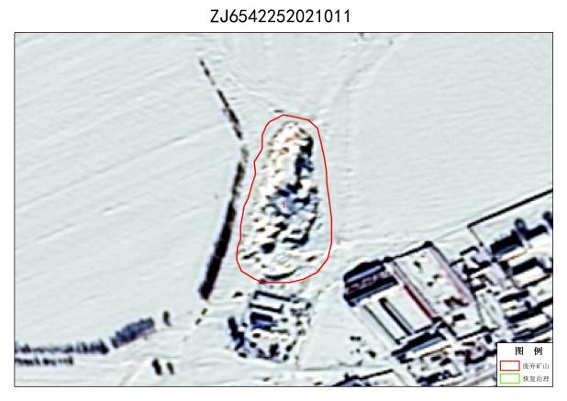
12 | ZJ6542252021015001 | 无法确认治理恢复责任主体的无主废弃矿山 | 塔城地区裕民县阿勒腾也木勒乡 | 36710.62 | 83.223206 | 46.137543 | 1.83.22201278,46.13885374  2.83.22221265,46.13887278  3.83.22239349,46.13889182  4.83.22268854,46.13889182  5.83.22328816,46.13892989  6.83.22351659,46.13889182  7.83.22372598,46.1386634  8.83.22375454,46.13831123  9.83.22382116,46.13799714  10.83.22398296,46.13758787  11.83.22403055,46.13725475  12.83.22406863,46.13702632  13.83.22421139,46.13662657  14.83.22441127,46.13641718  15.83.22454452,46.1360555  16.83.22443031,46.13567478  17.83.22417333,46.13559865  18.83.22391634,46.13581755  19.83.22355466,46.1361602  20.83.22334527,46.13638863  21.83.22321202,46.13657898  22.83.22307877,46.13668368  23.83.22285986,46.13681693  24.83.22255529,46.13707391  25.83.22242204,46.13731185  26.83.2222412,46.13758787  27.83.2220318,46.137921  28.83.22189856,46.13820654  29.83.22183193,46.13848255  30.83.22181289,46.13870146  31.83.22196518,46.13885375  32.83.22201278,46.13885374 | 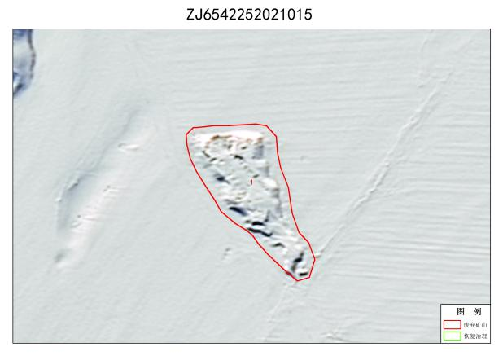
13 | ZJ6542252021023001 | 无法确认治理恢复责任主体的无主废弃矿山 | 塔城地区裕民县新地乡 | 76121.31 | 83.14274 | 46.28632 | 1.83.14135509,46.28660395  2.83.14211671,46.28697  3.83.14382353,46.28754766  4.83.14508771,46.28759583  5.83.14589062,46.28757058  6.83.14620549,46.28688624  7.83.14479494,46.28608033  8.83.14344971,46.28574383  9.83.14246881,46.28537351  10.83.14103974,46.28502363  11.83.1400272,46.28501548  12.83.13919607,46.28552584  13.83.13956787,46.28613587  14.83.14057764,46.28641901  15.83.14135509,46.28660395 | 